Registration for Debbie Rowleys “Fantasia” - www.DebBeesDesigns.com Quinsippi Needleworkers – April 13-14, 2024, Quincy, IL
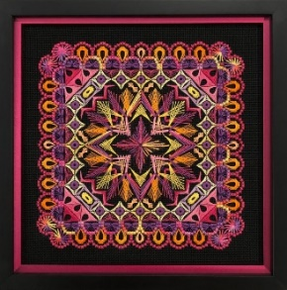

Ghosting: Registration fee $50, Kit fee $80, U.S. shipping $15 – Total fees $145 International shipping TBD by location, please inquire. Please view the color options on her website and designate your choice. ____ 1. 18ct. black canvas and bright colors as designed ____ 2. 18ct. white canvas and bright colors as designed
Fees are due February 29, 2024. Checks made payable to: Quinsippi Needleworkers
Name:___________________________________________________ Chapter (if applicable):__________________________________________________ Address:__________________________________________________ __________________________________________________ EGA membership (if applicable) #: _____________________ Email: ________________________________ Telephone: _____________________ Does your phone accept text messages? _____ yes _____ no
Welcome all “ghosts”!
Debbie will provide the videos & support to “ghosts” if they have questions. Kits should arrive sometime the week of April 15. A late fee will be assessed for registration/payment past the February 29, 2024.
Mail this registration and payment to either: Mary Ridder, 730 Birdie Lane, Quincy, IL 62305 (ridderfam@att.net) or Ann Bergman, 3512 N 12th, Quincy, IL 62305 (annbergman3@gmail.com)
Cancellation policy: Due to the extended registration date, and that these are “ghost” registrations, there is no cancallation.
Have fun and Enjoy!

